In [1]:

*#Name-Pawar ved balsaheb(T512037)* **import** matplotlib.pyplot **as** plt **import** numpy **as** np

**import** pandas **as** pd

**import** seaborn **as** sns

**%matplotlib** inline

**from** sklearn.metrics **import** mean_squared_error,mean_absolute_error,r2_score

In [3]:

temp_dataset **=** pd**.**read_csv('temperatures.csv') temp_dataset

Out[3]:

In [5]:

Out[5]:

In [7]:

temp_dataset**.**describe()**.**T

**YEAR JAN FEB MAR APR MAY JUN JUL AUG SEP OCT NOV**

**0** 1901 22.40 24.14 29.07 31.91 33.41 33.18 31.21 30.39 30.47 29.97 27.31 2

**1** 1902 24.93 26.58 29.77 31.78 33.73 32.91 30.92 30.73 29.80 29.12 26.31 2

**2** 1903 23.44 25.03 27.83 31.39 32.91 33.00 31.34 29.98 29.85 29.04 26.08 2

**3** 1904 22.50 24.73 28.21 32.02 32.64 32.07 30.36 30.09 30.04 29.20 26.36 2

**4** 1905 22.00 22.83 26.68 30.01 33.32 33.25 31.44 30.68 30.12 30.67 27.52 2

**...** ... ... ... ... ... ... ... ... ... ... ... ...

**112** 2013 24.56 26.59 30.62 32.66 34.46 32.44 31.07 30.76 31.04 30.27 27.83 2

**113** 2014 23.83 25.97 28.95 32.74 33.77 34.15 31.85 31.32 30.68 30.29 28.05 2

**114** 2015 24.58 26.89 29.07 31.87 34.09 32.48 31.88 31.52 31.55 31.04 28.10 2

**115** 2016 26.94 29.72 32.62 35.38 35.72 34.03 31.64 31.79 31.66 31.98 30.11 2

**116** 2017 26.45 29.46 31.60 34.95 35.84 33.82 31.88 31.72 32.22 32.29 29.60 2

117 rows × 18 columns

temp_dataset**.**shape

(117, 18)

|  |  |  |  |  |  |  |  |  |  |
| --- | --- | --- | --- | --- | --- | --- | --- | --- | --- |
| Out[7]: |  | **count** | **mean** | **std** | **min** | **25%** | **50%** | **75%** | **max** |
|  | **YEAR** | 117.0 | 1959.000000 | 33.919021 | 1901.00 | 1930.00 | 1959.00 | 1988.00 | 2017.00 |
|  | **JAN** | 117.0 | 23.687436 | 0.834588 | 22.00 | 23.10 | 23.68 | 24.18 | 26.94 |
|  | **FEB** | 117.0 | 25.597863 | 1.150757 | 22.83 | 24.78 | 25.48 | 26.31 | 29.72 |
|  | **MAR** | 117.0 | 29.085983 | 1.068451 | 26.68 | 28.37 | 29.04 | 29.61 | 32.62 |
|  | **APR** | 117.0 | 31.975812 | 0.889478 | 30.01 | 31.46 | 31.95 | 32.42 | 35.38 |
|  | **MAY** | 117.0 | 33.565299 | 0.724905 | 31.93 | 33.11 | 33.51 | 34.03 | 35.84 |
|  | **JUN** | 117.0 | 32.774274 | 0.633132 | 31.10 | 32.34 | 32.73 | 33.18 | 34.48 |
|  | **JUL** | 117.0 | 31.035897 | 0.468818 | 29.76 | 30.74 | 31.00 | 31.33 | 32.76 |
|  | **AUG** | 117.0 | 30.507692 | 0.476312 | 29.31 | 30.18 | 30.54 | 30.76 | 31.84 |
|  | **SEP** | 117.0 | 30.486752 | 0.544295 | 29.07 | 30.12 | 30.52 | 30.81 | 32.22 |
|  | **OCT** | 117.0 | 29.766581 | 0.705492 | 27.90 | 29.38 | 29.78 | 30.17 | 32.29 |
|  | **NOV** | 117.0 | 27.285470 | 0.714518 | 25.70 | 26.79 | 27.30 | 27.72 | 30.11 |
|  | **DEC** | 117.0 | 24.608291 | 0.782644 | 23.02 | 24.04 | 24.66 | 25.11 | 28.01 |
|  | **ANNUAL** | 117.0 | 29.181368 | 0.555555 | 28.11 | 28.76 | 29.09 | 29.47 | 31.63 |
|  | **JAN-FEB** | 117.0 | 24.629573 | 0.911239 | 22.25 | 24.11 | 24.53 | 25.15 | 28.33 |
|  | **MAR- MAY** | 117.0 | 31.517607 | 0.740585 | 29.92 | 31.04 | 31.47 | 31.89 | 34.57 |
|  | **JUN-SEP** | 117.0 | 31.198205 | 0.420508 | 30.24 | 30.92 | 31.19 | 31.40 | 32.41 |
|  | **OCT- DEC** | 117.0 | 27.208120 | 0.672003 | 25.74 | 26.70 | 27.21 | 27.61 | 30.03 |

In [9]:

temp_dataset**.**isnull()**.**sum()

Out[9]:

YEAR 0

JAN 0

FEB 0

MAR 0

APR 0

MAY 0

JUN 0

JUL 0

AUG 0

SEP 0

OCT 0

NOV 0

DEC 0

ANNUAL 0

JAN-FEB 0

MAR-MAY 0

JUN-SEP 0

OCT-DEC 0

dtype: int64

In [11]:

plt**.**figure(figsize**=**(10,6))

plt**.**plot(temp_dataset["YEAR"],temp_dataset**.**iloc[:,1:13]) plt**.**xlabel("Year")

plt**.**ylabel("Temperature")

plt**.**title("All Months(1901- 2017)")

plt**.**legend(["JAN","FEB","MAR","APR","MAY","JUN","JUL","AUG","SEP","OCT","NOV","D

plt**.**show()

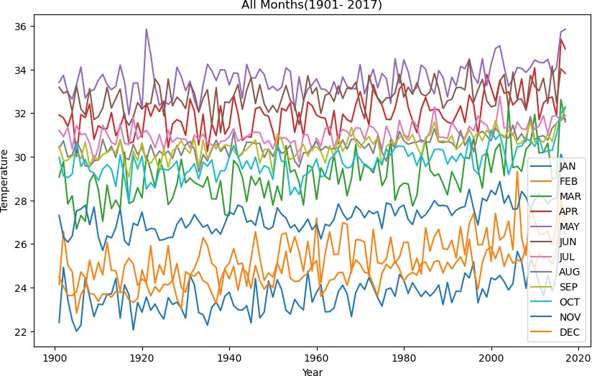

In [13]:

plt**.**plot(temp_dataset["YEAR"],temp_dataset["ANNUAL"]) plt**.**xlabel("Year")

plt**.**ylabel("Temperature")

plt**.**title("ANNUAL AVERAGE (1901- 2017)")

plt**.**show()

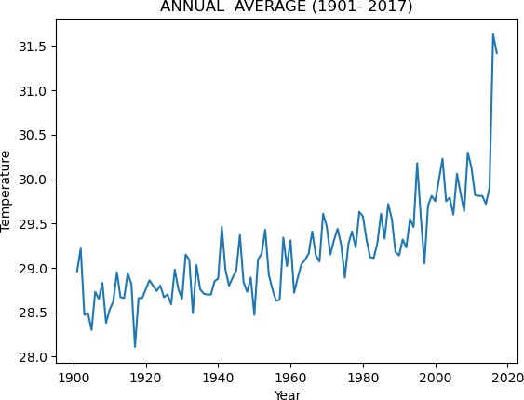

In [15]:

**from** sklearn.model_selection **import** train_test_split

**from** sklearn.linear_model **import** LinearRegression

X**=**temp_dataset[["YEAR"]] y**=**temp_dataset["JAN"]

X_train, X_test, y_train, y_test **=** train_test_split(X, y, test_size **=** 0.2, rando print(X_train**.**shape, X_test**.**shape)

*# instantiate the model*

lr **=** LinearRegression()

*# fit the model*

lr**.**fit(X_train, y_train)

*#predicting the target value from the model for the samples*

y_test_lr **=** lr**.**predict(X_test)

y_train_lr **=** lr**.**predict(X_train)

(93, 1) (24, 1)

In [17]:

print("Intercept",lr**.**intercept_) print("Slope",lr**.**coef_)

Intercept 0.04088196282960865

Slope [0.01206848]

In [19]:

*#computing the accuracy of the model performance*

acc_train_lr **=** lr**.**score(X_train, y_train) acc_test_lr **=** lr**.**score(X_test, y_test)

*#computing root mean squared error (RMSE)*

rmse_train_lr **=** np**.**sqrt(mean_squared_error(y_train, y_train_lr))

rmse_test_lr **=** np**.**sqrt(mean_squared_error(y_test, y_test_lr))

print("Linear Regression: Accuracy on training Data: {:.3f}"**.**format(acc_train_lr print("Linear Regression: Accuracy on test Data: {:.3f}"**.**format(acc_test_lr))

print('\nLinear Regression: The RMSE of the training set is:', rmse_train_lr) print('Linear Regression: The RMSE of the testing set is:', rmse_test_lr)

Linear Regression: Accuracy on training Data: 0.264 Linear Regression: Accuracy on test Data: 0.460

Linear Regression: The RMSE of the training set is: 0.6660910902332355 Linear Regression: The RMSE of the testing set is: 0.7461610613861772

In [21]:

*#visulaize annaul temperature*

plt**.**plot(X,y)

plt**.**xlabel("Year")

plt**.**ylabel("Temperature")

plt**.**title("Annual Temperature from 1901-2017") plt**.**show()

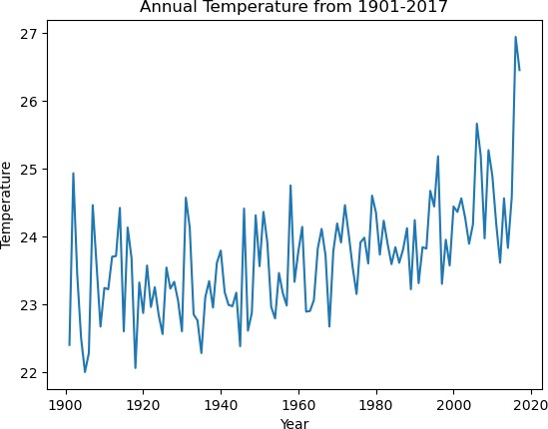

In [23]:

*# Visualization*

*#plt.figure(figsize=(8, 6))*

plt**.**scatter(X_test,y_test,color **=** 'blue'); plt**.**scatter(X_train,y_train,color **=** 'red');

plt**.**plot(X_train,lr**.**predict(X_train), color **=** 'black');

plt**.**legend(['Best fit Regression lIne','Testing Set','Training Set']) plt**.**title('Temperature vs Year for month Jan')

plt**.**xlabel('Year')

plt**.**ylabel('Temperature') plt**.**show();

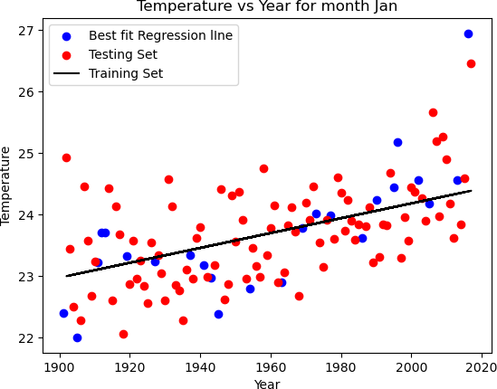

In [25]:

*#Errors for month Jan*

print('R-Squared Error :',r2_score(y_test,y_test_lr))

print('Mean Absolute Error :',mean_absolute_error(y_test,y_test_lr)) print('Mean Squared Error :',mean_squared_error(y_test,y_test_lr))

print('Root Mean Squared Error :',np**.**sqrt(mean_squared_error(y_test,y_test_lr)))

R-Squared Error : 0.4601171648515957

Mean Absolute Error : 0.5083956669577453 Mean Squared Error : 0.5567563295289465

Root Mean Squared Error : 0.7461610613861772

In [27]:

*# Split the dataset into training and testing*

**from** sklearn.model_selection **import** train_test_split

**from** sklearn.linear_model **import** LinearRegression

X**=**temp_dataset[["YEAR"]] y**=**temp_dataset["FEB"]

X_train, X_test, y_train, y_test **=** train_test_split(X, y, test_size **=** 0.2, rando print(X_train**.**shape, X_test**.**shape)

*# instantiate the model* lr **=** LinearRegression() *# fit the model*

lr**.**fit(X_train, y_train)

*#predicting the target value from the model for the samples*

y_test_lr **=** lr**.**predict(X_test)

y_train_lr **=** lr**.**predict(X_train)

(93, 1) (24, 1)

In [29]:

print("Intercept",lr**.**intercept_) print("Slope",lr**.**coef_)

Intercept -13.589454788386252

Slope [0.01998518]

In [31]:

*#computing the accuracy of the model performance*

acc_train_lr **=** lr**.**score(X_train, y_train) acc_test_lr **=** lr**.**score(X_test, y_test)

*#computing root mean squared error (RMSE)*

rmse_train_lr **=** np**.**sqrt(mean_squared_error(y_train, y_train_lr)) rmse_test_lr **=** np**.**sqrt(mean_squared_error(y_test, y_test_lr))

print("Linear Regression: Accuracy on training Data: {:.3f}"**.**format(acc_train_lr print("Linear Regression: Accuracy on test Data: {:.3f}"**.**format(acc_test_lr))

print('\nLinear Regression: The RMSE of the training set is:', rmse_train_lr) print('Linear Regression: The RMSE of the testing set is:', rmse_test_lr)

Linear Regression: Accuracy on training Data: 0.366 Linear Regression: Accuracy on test Data: 0.534

Linear Regression: The RMSE of the training set is: 0.8686967555951215 Linear Regression: The RMSE of the testing set is: 0.9079689831221699

In [33]:

*#visulaize annaul temperature*

plt**.**plot( X,y )

plt**.**xlabel("Year")

plt**.**ylabel("Temperature")

plt**.**title("Annual Temperature from 1901-2017") plt**.**show()

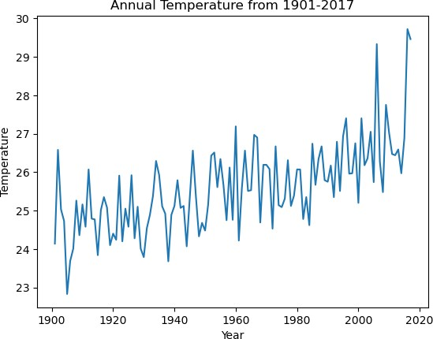

In [35]:

*# Visualization*

*#plt.figure(figsize=(12, 9))*

plt**.**scatter(X_test,y_test,color **=** 'blue'); plt**.**scatter(X_train,y_train,color **=** 'red');

plt**.**plot(X_train,lr**.**predict(X_train), color **=** 'black');

plt**.**legend(['Best fit Regression lIne','Testing Set','Training Set']) plt**.**title('Temperature vs Year for month Feb')

plt**.**ylabel('Temperature') plt**.**xlabel('Year')

plt**.**show();

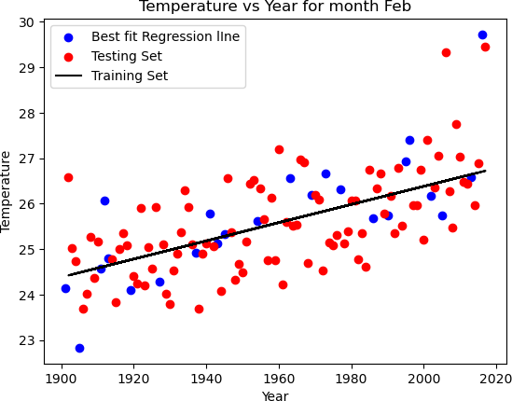

In [37]:

*#Errors for month Feb*

print('R-Squared Error :',r2_score(y_test,y_test_lr))

print('Mean Absolute Error :',mean_absolute_error(y_test,y_test_lr)) print('Mean Squared Error :',mean_squared_error(y_test,y_test_lr))

print('Root Mean Squared Error :',np**.**sqrt(mean_squared_error(y_test,y_test_lr)))

R-Squared Error : 0.5337774396814265

Mean Absolute Error : 0.6321543551026766 Mean Squared Error : 0.8244076743119072

Root Mean Squared Error : 0.9079689831221699

In [39]:

*# Split the dataset into training and testing*

**from** sklearn.model_selection **import** train_test_split

**from** sklearn.linear_model **import** LinearRegression

X**=**temp_dataset[["YEAR"]] y**=**temp_dataset["MAR"]

X_train, X_test, y_train, y_test **=** train_test_split(X, y, test_size **=** 0.2, rando print(X_train**.**shape, X_test**.**shape)

*# instantiate the model* lr **=** LinearRegression() *# fit the model*

lr**.**fit(X_train, y_train)

*#predicting the target value from the model for the samples*

y_test_lr **=** lr**.**predict(X_test)

y_train_lr **=** lr**.**predict(X_train)

(93, 1) (24, 1)

In [41]:

print("Intercept",lr**.**intercept_) print("Slope",lr**.**coef_)

Intercept 0.8326151493664895

Slope [0.01439656]

In [43]:

*#computing the accuracy of the model performance*

acc_train_lr **=** lr**.**score(X_train, y_train) acc_test_lr **=** lr**.**score(X_test, y_test)

*#computing root mean squared error (RMSE)*

rmse_train_lr **=** np**.**sqrt(mean_squared_error(y_train, y_train_lr)) rmse_test_lr **=** np**.**sqrt(mean_squared_error(y_test, y_test_lr))

print("Linear Regression: Accuracy on training Data: {:.3f}"**.**format(acc_train_lr print("Linear Regression: Accuracy on test Data: {:.3f}"**.**format(acc_test_lr))

print('\nLinear Regression: The RMSE of the training set is:', rmse_train_lr) print('Linear Regression: The RMSE of the testing set is:', rmse_test_lr)

Linear Regression: Accuracy on training Data: 0.234 Linear Regression: Accuracy on test Data: 0.412

Linear Regression: The RMSE of the training set is: 0.8613784589579908 Linear Regression: The RMSE of the testing set is: 1.0069570422964147

In [45]:

*#visulaize annaul temperature*

plt**.**plot( X,y )

plt**.**xlabel("Year")

plt**.**ylabel("Temperature")

plt**.**title("Annual Temperature from 1901-2017") plt**.**show()

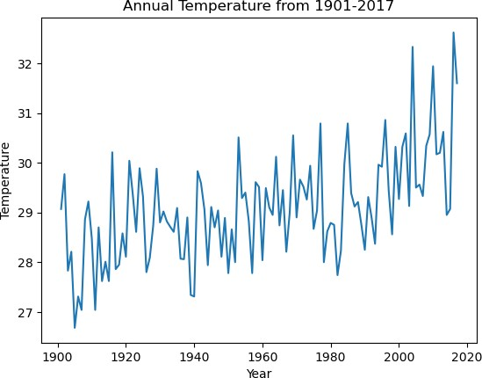

In [47]:

*# Visualization*

*#plt.figure(figsize=(12, 9))*

plt**.**scatter(X_test,y_test,color **=** 'blue'); plt**.**scatter(X_train,y_train,color **=** 'red');

plt**.**plot(X_train,lr**.**predict(X_train), color **=** 'black');

plt**.**legend(['Best fit Regression lIne','Testing Set','Training Set']) plt**.**title('Temperature vs Year for month March')

plt**.**ylabel('Temperature') plt**.**xlabel('Year')

plt**.**show();

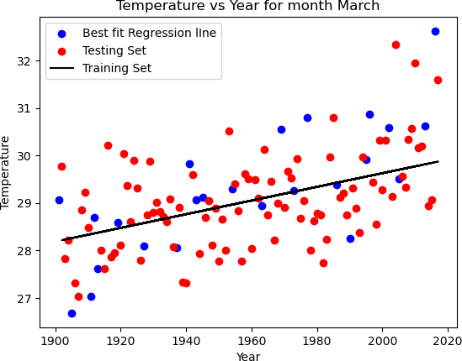

In [49]:

*#Errors for month March*

print('R-Squared Error :',r2_score(y_test,y_test_lr))

print('Mean Absolute Error :',mean_absolute_error(y_test,y_test_lr)) print('Mean Squared Error :',mean_squared_error(y_test,y_test_lr))

print('Root Mean Squared Error :',np**.**sqrt(mean_squared_error(y_test,y_test_lr)))

R-Squared Error : 0.41193423910621496

Mean Absolute Error : 0.7784057105758042 Mean Squared Error : 1.0139624850303435

Root Mean Squared Error : 1.0069570422964147

In [51]:

*# Split the dataset into training and testing*

**from** sklearn.model_selection **import** train_test_split

**from** sklearn.linear_model **import** LinearRegression

X**=**temp_dataset[["YEAR"]] y**=**temp_dataset["MAR-MAY"]

X_train, X_test, y_train, y_test **=** train_test_split(X, y, test_size **=** 0.2, rando print(X_train**.**shape, X_test**.**shape)

*# instantiate the model* lr **=** LinearRegression() *# fit the model*

lr**.**fit(X_train, y_train)

*#predicting the target value from the model for the samples*

y_test_lr **=** lr**.**predict(X_test)

y_train_lr **=** lr**.**predict(X_train)

(93, 1) (24, 1)

In [53]:

print("Intercept",lr**.**intercept_) print("Slope",lr**.**coef_)

Intercept 6.838794003180691

Slope [0.01258417]

In [55]:

*#computing the accuracy of the model performance*

acc_train_lr **=** lr**.**score(X_train, y_train) acc_test_lr **=** lr**.**score(X_test, y_test)

*#computing root mean squared error (RMSE)*

rmse_train_lr **=** np**.**sqrt(mean_squared_error(y_train, y_train_lr)) rmse_test_lr **=** np**.**sqrt(mean_squared_error(y_test, y_test_lr))

print("Linear Regression: Accuracy on training Data: {:.3f}"**.**format(acc_train_lr print("Linear Regression: Accuracy on test Data: {:.3f}"**.**format(acc_test_lr))

print('\nLinear Regression: The RMSE of the training set is:', rmse_train_lr) print('Linear Regression: The RMSE of the testing set is:', rmse_test_lr)

Linear Regression: Accuracy on training Data: 0.381 Linear Regression: Accuracy on test Data: 0.445

Linear Regression: The RMSE of the training set is: 0.5297583992887077 Linear Regression: The RMSE of the testing set is: 0.7002924995190984

In [57]:

*#visulaize annaul temperature*

plt**.**plot(X,y)

plt**.**xlabel("Year")

plt**.**ylabel("Temperature")

plt**.**title("Annual Temperature from 1901-2017") plt**.**show()

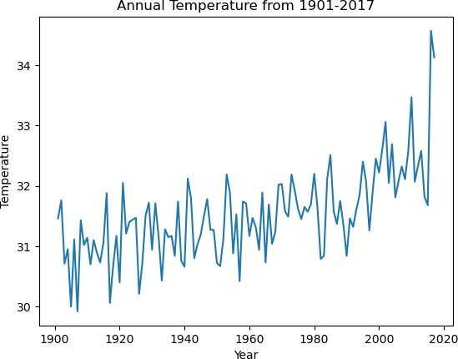

In [59]:

*# Visualization*

*#plt.figure(figsize=(12, 9))*

plt**.**scatter(X_test,y_test,color **=** 'blue'); plt**.**scatter(X_train,y_train,color **=** 'red');

plt**.**plot(X_train,lr**.**predict(X_train), color **=** 'black');

plt**.**legend(['Best fit Regression lIne','Testing Set','Training Set']) plt**.**title('Temperature vs Year for month March-May')

plt**.**ylabel('Temperature') plt**.**xlabel('Year')

plt**.**show();

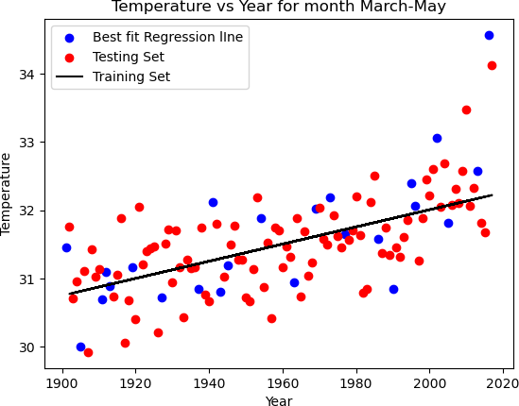

In [61]:

*#Errors for month Mar-May*

print('R-Squared Error :',r2_score(y_test,y_test_lr))

print('Mean Absolute Error :',mean_absolute_error(y_test,y_test_lr)) print('Mean Squared Error :',mean_squared_error(y_test,y_test_lr))

print('Root Mean Squared Error :',np**.**sqrt(mean_squared_error(y_test,y_test_lr)))

R-Squared Error : 0.4448244662589811

Mean Absolute Error : 0.5121496378249248 Mean Squared Error : 0.49040958488270653

Root Mean Squared Error : 0.7002924995190984

In [ ]: